INTERNSHIP REPORT

*A report submitted in partial fulfillment of the requirements for the Award of Degree of*

## BACHELOR OF TECHNOLOGY

**in**

## COMPUTER SCIENCE AND ENGINEERING

**by**

**C.Yamini**

## Regd. No.: VU21CSEN0100351

**Under Supervision of**

**OCTANET SERVICES**

## Visakhapatnam.

**(Duration: 1st February 2024 to 1st March 2024)**



## DEPARTMENT OF COMPUTER SCIENCE AND ENGINEERING GITAM SCHOOL OF TECHNOLOGY

## GITAM(Deemed to be University)

## VISAKHAPATNAM,

## ANDHRA PRADESH

## 2023 – 2024

**DEPARTMENT OF COMPUTER SCIENCE AND ENGINEERING GITAM SCHOOL TECHNOLOGY**

**GITAM(Deemed to be University)**

VISAKHAPTNAM



***CERTIFICATE***

This is to certify that the “**Internship report”** submitted by C.**Yamini (Regd. No.: VU21CSEN0100351)** is work done by her and submitted during 2023 – 2024 academic year, in partial fulfillment of the requirements for the award of the degree of **BACHELOR OF TECHNOLOGY in COMPUTER SCIENCE AND ENGINEERING,** at OCTANET SERVICES PVT LTD**.**

**Head of the Department Internship Faculty**Dr. Gondi Lakshmeeswari Dr S. Amarnadh



**Acknowledgement:**

I am deeply grateful to everyone who has contributed to making my online internship at Octanet Services Pvt Ltd a valuable and enriching experience.

First and foremost, I extend my heartfelt thanks to Dr. Amarnadh for his exceptional guidance, support, and mentorship throughout the duration of the internship. His expertise, encouragement, and dedication to my professional growth have been invaluable, and I am immensely grateful for the opportunity to learn from him.

Lastly, I would like to acknowledge the support and encouragement of the academic staff at my institution, whose guidance and support have prepared me for this internship opportunity.

I am truly grateful to every individual who has played a part in making this internship experience memorable and rewarding for me.

C.Yamini

VU21CSEN0100351

**INDEX**

|  |  |  |
| --- | --- | --- |
| S.NO | TITLE | PAGE NUMBER |
| 1 | Introduction | 1 |
| 2 | Problem Statement | 2 |
| 3 | Objective | 3 |
| 4 | Software Requirement Specifications | 4 |
| 5 | Technologies | 5 |
| 6 | Methodologies | 6 |
| 7 | Sample Coding | 7-16 |
| 8 | Results & Discussions | 17-22 |
| 9 | Conclusion | 23 |
| 10 | References | 24 |

**ABSTRACT**

The "Flying Wheel" web page aims to provide a seamless online experience for customers interested in bicycles and cycling-related products and services

It is designed to offer an intuitive and enjoyable online platform for individuals passionate about bicycles and related products and services. Its primary goal is to advocate for cycling as a sustainable and healthy means of transportation and recreation. It focuses on promoting cycling as a healthy and eco-friendly mode of transportation and leisure activity.

The website emphasizes user-friendly navigation and a visually appealing layout to enhance the overall experience for visitors. Through engaging content and interactive features, such as product showcases, cycling tips, and community forums, the "Flying Wheel" aims to inspire and support cycling enthusiasts of all levels.

Overall, the "Flying Wheel" web page strives to create a seamless and enjoyable online environment that encourages and fosters a love for cycling while promoting sustainability and eco-consciousness among its users.

Top of Form

**1. INTRODUCTION**

The "Flying Wheel" web page is designed to give visitors a comprehensive understanding of the shop's core mission, vision, and values. It will convey the following key points:

# 1.1 Mission:

# The introduction will outline the shop's mission, which is likely centered around promoting cycling as a sustainable and healthy lifestyle choice. It may emphasize the benefits of cycling for individuals and communities, such as improved health, reduced environmental impact, and enhanced mobility.

# 1.2 Vision:

# The section will also articulate the shop's vision for the future of cycling, highlighting its aspirations and goals. This could include fostering a vibrant cycling culture, increasing awareness and participation in cycling-related activities, and contributing to a greener and more sustainable world.

# 1.3 Values:

# The introduction will touch upon the core values that guide the shop's operations and interactions with customers and the cycling community.

# 1.4 Product and Service Offerings:

# Additionally, the introduction will briefly mention the shop's offerings, such as high-quality bicycles, accessories, and services aimed at enhancing customers' cycling experiences.

**1**

**2. PROBLEM STATEMENT**

The problem statement for "Flying Wheel" could address common challenges faced by cyclists, such as limited access to quality cycling equipment, lack of cycling infrastructure awareness, and the need for reliable maintenance.

**2.1 Limited Access to Quality Cycling Equipment**:

Many cyclists struggle to find high-quality bicycles and accessories that meet their specific needs and preferences. This can be due to limited availability of specialized equipment, especially in areas with fewer cycling shops or limited product variety.

**2.2 Lack of Cycling Infrastructure Awareness**:

In some regions, there may be a lack of awareness or information about cycling infrastructure. The problem statement can highlight how the "Flying Wheel" not only provides products but also promotes cycling awareness and advocacy

**2.3 Need for Reliable Maintenance:**

Cyclists often face issues with bike maintenance, repairs, and servicing, which can impact their riding experience and safety. Finding reliable and skilled mechanics or bike shops for maintenance can also be a challenge

**2**

**3.OBJECTIVE**

The objective of the "Flying Wheel" web page is to create a user-friendly platform that offers a wide range of bicycles, accessories, and services while promoting cycling culture, safety, and sustainability. It aims to attract new customers, retain loyal cyclists, and contribute positively to the cycling community.

**3.1 User-Friendly Platform:**

The primary goal is to design a website that is intuitive, easy to navigate, and visually appealing. This includes clear categorization of products, a streamlined checkout process, responsive design for mobile users, and engaging content that educates and inspires visitors about cycling.

**3.2 Promotion of Cycling Culture:**

The "Flying Wheel" intends to promote a vibrant cycling culture by featuring content that celebrates the joy of cycling, shares inspiring stories from cyclists, and highlights community events and initiatives related to cycling advocacy and awareness.

**3.3 Safety Awareness**:

Safety is a paramount concern for cyclists, and the web page will incorporate resources and information on safe cycling practices, traffic rules for cyclists, tips for navigating urban environments, and guides on bike maintenance and care to ensure a safe riding experience.

**3**

**4.SOFTWARE REQUIREMENT SPECIFICATIONS**

The software requirement specifications for "Flying Wheel" may include a responsive and intuitive website design compatible with various devices and browsers. It should incorporate inventory management systems and analytical capabilities for business insights.

**4.1 Responsive and Intuitive Website Design:**

* The website must be responsive, ensuring optimal viewing and interaction across a wide range of devices, including desktops, laptops, tablets, and smartphones.
* It should have a user-friendly and intuitive interface, with clear navigation menus, search functionality, and easy access to product categories, services, and informational content.
* Compatibility with various web browsers such as Google Chrome, Mozilla Firefox, Safari, and Microsoft Edge is crucial to ensure a seamless experience for all users.

**4.2 Inventory Management Systems:**

* The website requires robust inventory management systems to track and manage product stock levels, availability, and variations (e.g., sizes, colors).
* It should support real-time updates, automated notifications for low stock levels, and alerts for out-of-stock items to facilitate timely restocking and inventory control.
* Integration with a backend database or inventory management software is necessary to synchronize online inventory data with physical stock levels accurately.

**4**

**5 TECHNOLOGIES**

The technologies used for the "Flying Wheel" web page may include HTML, CSS3, JavaScript for front-end development, a server-side language like PHP and a database system such as php my admin for data management.

**5.1 HTML (Hypertext Markup Language):**

* HTML is the fundamental markup language used for creating the structure and content of web pages. It provides the basic elements such as headings, paragraphs, images, links, and forms.

**5.2 CSS3 (Cascading Style Sheets):**

* CSS3 is a style sheet language that controls the presentation and styling of HTML elements on a web page. It allows designers to customize fonts, colours, layouts, and visual effects.

**5.3 JavaScript:**

* JavaScript is a scripting language used for adding interactivity, dynamic content, and behaviour to web pages. It enables functionalities such as animations, form validation, user interactions, and dynamic updates without reloading the entire page.

**5.4** **Database System (e.g., phpMyAdmin):**

* A database system such as phpMyAdmin, which is a graphical interface for managing MySQL databases, will be used for storing, organizing, and retrieving data related to products, user accounts, orders, and website content.

**5**

**6.METHODOLOGIES**

The methodologies employed for developing the "Flying Wheel" web page may include agile practices for iterative development.

**6.1 Agile Methodology**

* Utilize agile principles and practices for iterative development, collaboration, and flexibility in responding to changing requirements.
* Adopt Scrum or Kanban frameworks to organize development sprints, prioritize tasks, and track progress through regular sprint reviews and retrospectives.

**6.2 Incremental Development**

* The iterative approach involves breaking down the development process into smaller increments or iterations.
* Each iteration focuses on implementing specific features or functionalities based on priority and feedback. This incremental approach allows for continuous refinement and enhancement of the website, ensuring that customer needs are met effectively.

**6**

**7 SAMPLE CODING**

**7.1 Main page:**

<!DOCTYPE html>

<html lang="en">

<head>

    <meta charset="UTF-8">

    <meta name="viewport" content="width=device-width, initial-scale=1.0">

    <title>Flying Wheel</title>

    <style>

        * {

            margin: 0;

            padding: 0;

            box-sizing: border-box;

        }

        body {

            font-family: Arial, sans-serif;

            background-color: #f0f0f0;

            color: #333;

        }

        header {

            background-color: #333;

            color: #fff;

            padding: 20px;

            text-align: center;

            display: flex;

            flex-direction: column;

            align-items: flex-start;

        }

        header h1 {

            margin-bottom: 10px;

        }

**7**

        header .links {

            display: flex;

        }

        header .links a {

            margin-right: 10px;

            color: #fff;

            text-decoration: none;

            font-weight: bold;

            padding: 5px 10px;

            border: 2px solid #fff;

            border-radius: 5px;

        }

        main {

            padding: 20px;

        }

        section {

            margin-bottom: 20px;

        }

        .bikes {

            display: flex;

            flex-wrap: wrap;

            justify-content: space-around;

        }

.bike {

            flex: 0 0 45%;

            background-color: #fff;

            border: 1px solid #ccc;

            padding: 20px;

            margin-bottom: 20px;

            display: flex;

            flex-direction: column;

            align-items: center;

**8**

        }

        .bike img {

            width: 100%;

            max-width: 200px;

            height: auto;

            margin-bottom: 10px;

        }

        footer {

            background-color: #333;

            color: #fff;

            padding: 10px 20px;

            text-align: center;

        }

    </style>

</head>

<body>

<header>

    <h1>Flying Wheel</h1>

    <div class="links">

        <a href="login.html">Login</a>

        <a href="offers.html">Offers</a>

        <a href="products.html">Products</a>

        <a href="typesbikes.html">Types</a>

        <a href="http://localhost/internship/signup.php">Sign up</a>

</div>

</header>

<main>

    <section class="featured">

        <h2>Featured Bikes</h2>

        <div class="bikes">

            <div class="bike">

                <img src="bike1.jpg" alt="Bike 1">

**9**

<div><p>Keep calm and pedal on.</p></div>

            </div>

            <div class="bike">

                <img src="bike2.jpg" alt="Bike 2">

                <div><p>Premium bicycles for all ages</p></div>

            </div>

        </div>

    </section>

    <section class="about">

        <h2>ABOUT US</h2>

        <p>Welcome to Cycle Shop, where we provide high-quality bikes for all your cycling needs.</p>

        <p>We are super happy to provide you with all the services.</p>

        <p>Our mission is to provide high-quality bicycles, accessories, and exceptional customer service to help you enjoy every ride to the fullest.</p>

        <p>With a wide range of bikes for all ages and skill levels, along with expert advice and maintenance services, we're here to support you every step of the way on your cycling journey.</p>

        <p>Visit us today and let's pedal towards adventure together!</p>

        </section>

    <section class="contact">

        <h2>CONTACT US</h2>

        <p>For Booking, Contact to the below number or gmail.</p>

        <p>lkr@gmail.com</p>

        <p>8975642369</p>

    </section>

</main>

<footer>

    <p>&copy; Cycle Shop</p>

</footer>

</body>

</html>

**10**

**7.2 Login page**

<!DOCTYPE html>

<html lang="en">

<head>

    <meta charset="UTF-8">

    <meta name="viewport" content="width=device-width, initial-scale=1.0">

    <title>Login Page</title>

    <style>

        body {

            font-family: Arial, sans-serif;

            margin: 0;

            padding: 0;

            display: flex;

            justify-content: center;

            align-items: center;

            height: 100vh;

            background-image: url('bgp.jpg');

            background-size: cover;

        }

        .login-container {

            background-color: rgba(255, 255, 255, 0.8);

            padding: 20px;

            border-radius: 5px;

            box-shadow: 0px 0px 10px 0px rgba(0,0,0,0.1);

        }

        h2 {

            margin-top: 0;

            margin-bottom: 20px;

        }

input[type="text"],

        input[type="password"],

        button {

            width: 100%;

**11**

padding: 10px;

            margin-bottom: 10px;

            border: 1px solid #ccc;

            border-radius: 3px;

        }

        button {

            background-color: black;

            color: #fff;

            border: none;

            cursor: pointer;

        }

        button:hover {

            background-color: black;

        }

        .forgot-password {

            text-align: center;

            margin-top: 10px;

        }

        .forgot-password a {

            color: blue;

            text-decoration: none;

        }

        .forgot-password a:hover {

            text-decoration: underline;

        }

    </style>

</head>

<body>

    <div class="login-container">

        <h2>Login</h2>

        <form id="loginForm">

**12**

<input type="text" id="username" placeholder="Username" required>

            <input type="password" id="password" placeholder="Password" required>

            <button type="submit">Login</button>

        </form>

        <div class="forgot-password">

            <a href="forgot_password.html">Forgot Password?</a>

        </div>

    </div>

    <script>

        document.getElementById("loginForm").addEventListener("submit", function(event) {

            event.preventDefault();

            var username = document.getElementById("username").value;

            var password = document.getElementById("password").value;

            var hardcodedUsername = "admin";

            var hardcodedPassword = "password";

            if (username === hardcodedUsername && password === hardcodedPassword) {

                window.location.href = "landingpage.html";

            } else {

                alert("Invalid username or password");

            }

        });

    </script>

</body>

</html>

**13**

**7.3 Offers Page**

<!DOCTYPE html>

<html lang="en">

<head>

<meta charset="UTF-8">

<meta name="viewport" content="width=device-width, initial-scale=1.0">

<title>Offers</title>

<style>

    body {

        font-family: Arial, sans-serif;

        margin: 0;

        padding: 0;

        background-image: url('offer.jpg'); /* Replace 'bg.jpg' with the path to your background image */

        background-size: cover;

        background-position: center;

        background-repeat: no-repeat;

    }

    header {

        background-color: #333;

        color: whitesmoke;

        padding: 10px 0;

        text-align: center;

    }

    .container {

        max-width: 1200px;

        margin: 20px auto;

        padding: 0 20px;

    }

    .offer {

        background-color:whitesmoke;

        border-radius: 5px;

        box-shadow: 0 2px 5px rgba(0, 0, 0, 0.1);

        padding: 20px;

        margin-bottom: 20px;

    }

**14**

.offer h2 {

        margin-top: 0;

    }

    .offer p {

        margin-bottom: 10px;

    }

    .offer .price {

        font-size: 24px;

        font-weight: bold;

    }

    .offer .discount {

        color: #ff5733;

    }

    footer {

        background-color: #333;

        color: #fff;

        text-align: center;

        padding: 10px 0;

        position: fixed;

        bottom: 0;

        width: 100%;

    }

</style>

</head>

<body>

<header>

    <h1>Offers</h1>

</header>

<div class="container">

    <div class="offer">

        <h2>Offer</h2>

        <p>Special offers on Mountain Bikes.</p>

        <p class="price">Price: 20,000 <span class="discount">(20% off)</span></p>

**15**

  </div>

    <div class="offer">

        <h2>Offer</h2>

        <p>Amazing discount on helmets. </p>

        <p class="price">Price: 3,000 <span class="discount"> (15% off) </span></p>

    </div>

    <div class="offer">

        <h2>Offer</h2>

        <p>Flat RS 500 off on bikes above Rs 10,000</p>

    </div>

</div>

<footer>

    <p>&copy; 2024 Cycle Shop. All rights reserved.</p>

</footer>

</body>

</html>

**16**

**8.RESULTS & DISCUSSIONS**

**8.1 Home page**

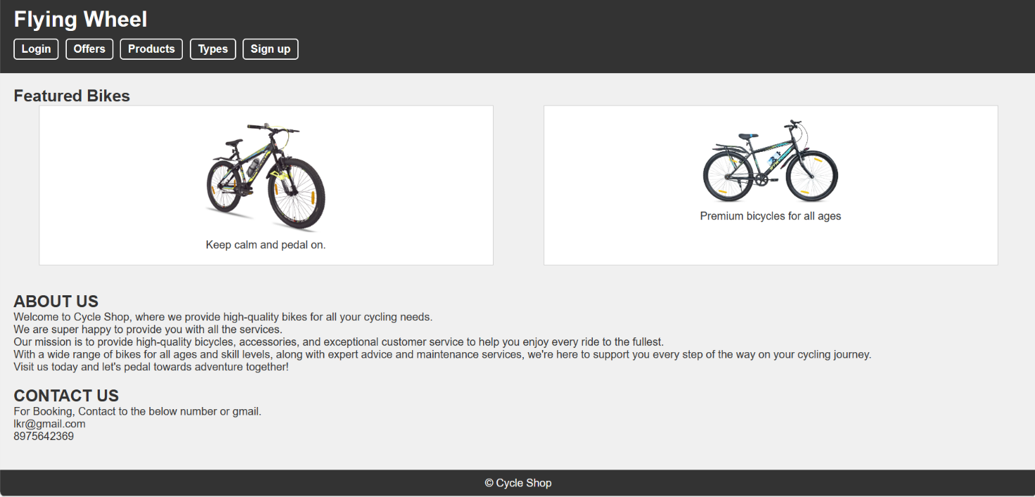

**Figure:1** - The Home Page of the Website

**8.2 Login Page**



**Figure:2** – The Login Page of the Website

**17**

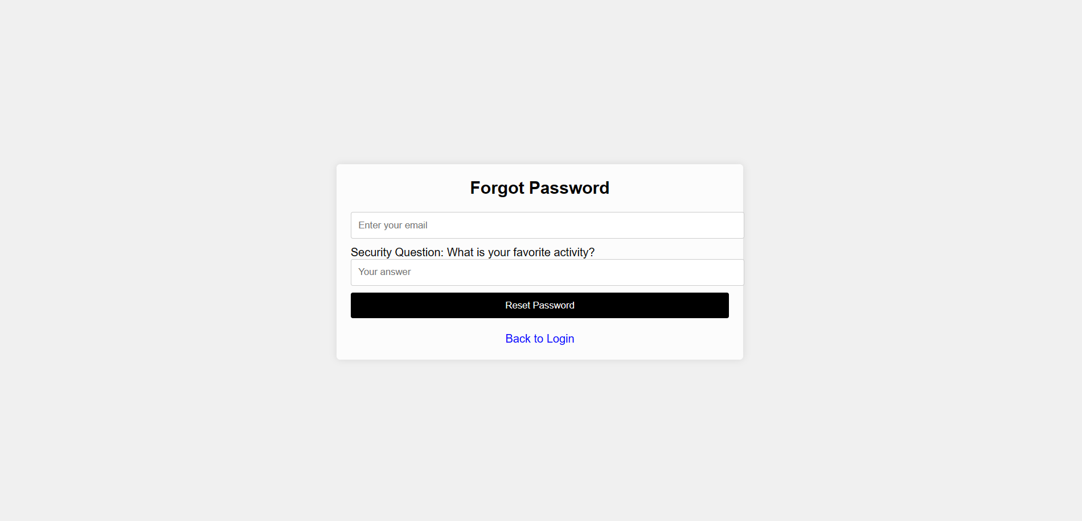

**Figure:3** – Forgot Password Page, Incase the user forgets the password

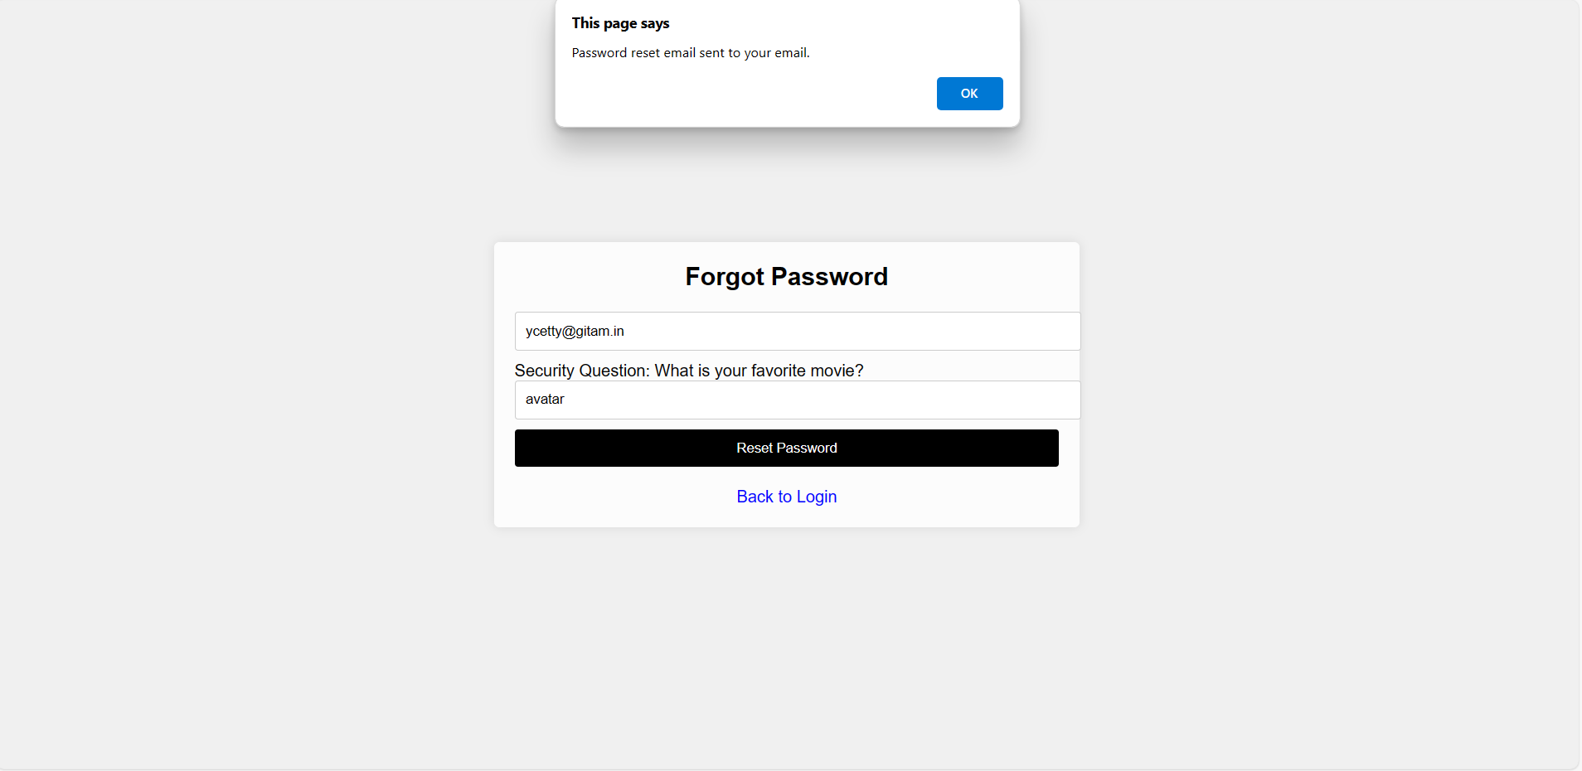

**Figure:4** – Forgot Password Page, when the questions are correctly answered.

**18**

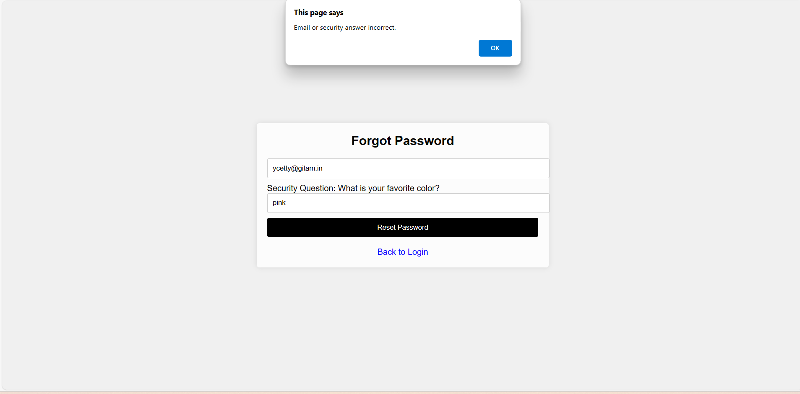

**Figure:5** – Forgot Password Page, when the questions are not answered correctly

**8.3 Database connectivity**

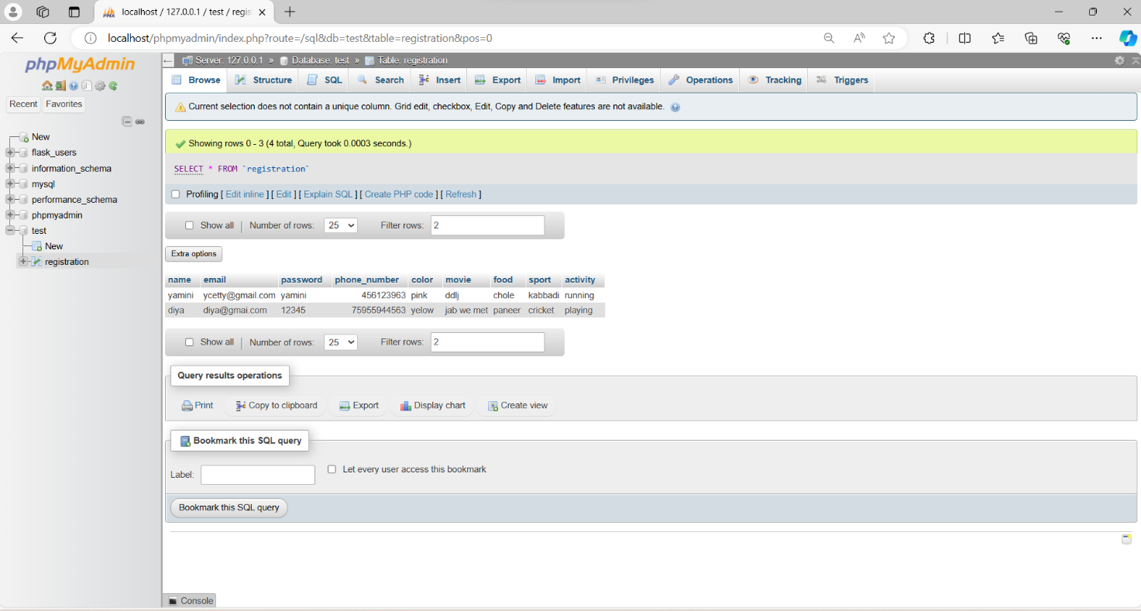

**Figure 6: -** Values stored in the database

**19**

**8.4 Offers Page**

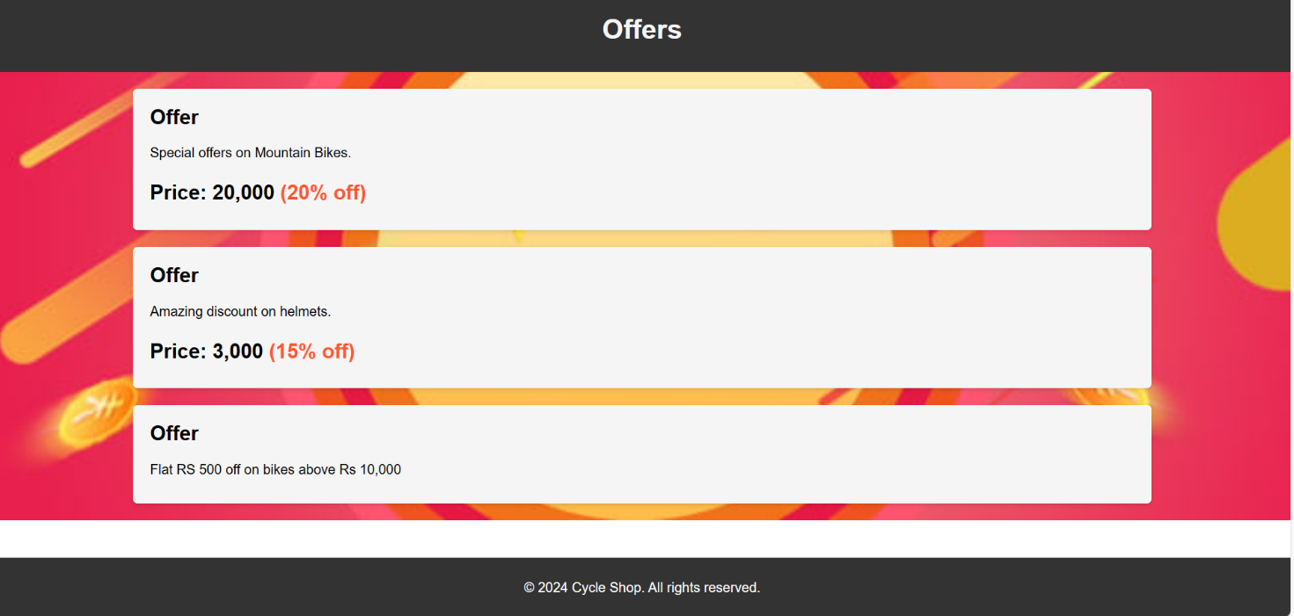

**Figure 7: -**This page displays the currently available offers on the website

**8.5 Products**

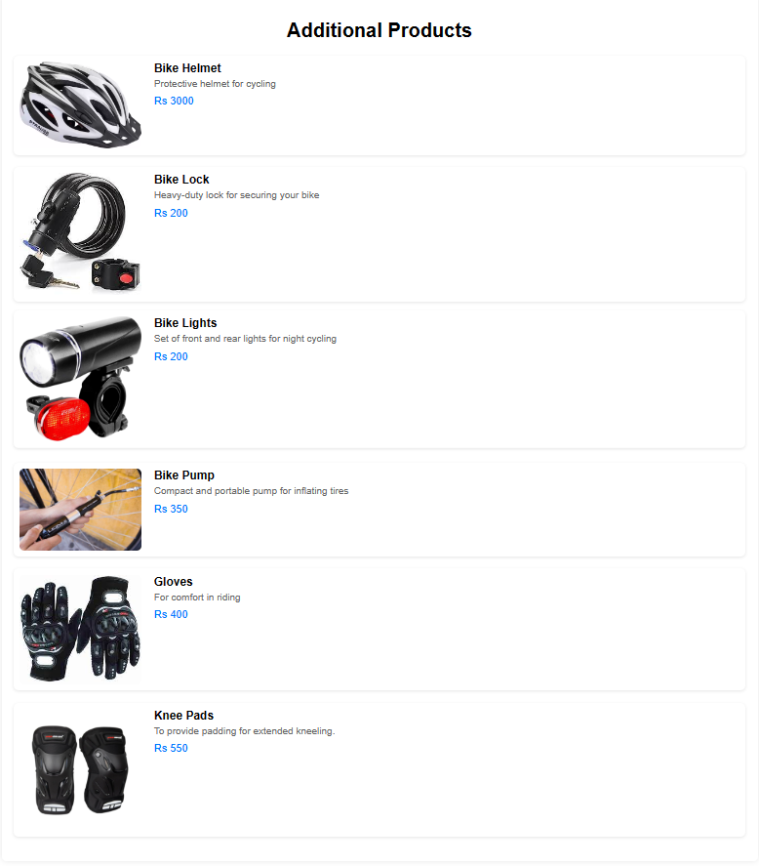**Figure 8: -**This Page shows the additional products sold other than the cycles.

**20**

**8.6 Types of Cycles Page**

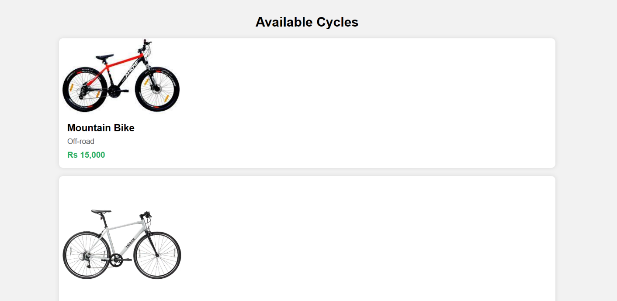

**Figure 9: -** Different types of cycles available

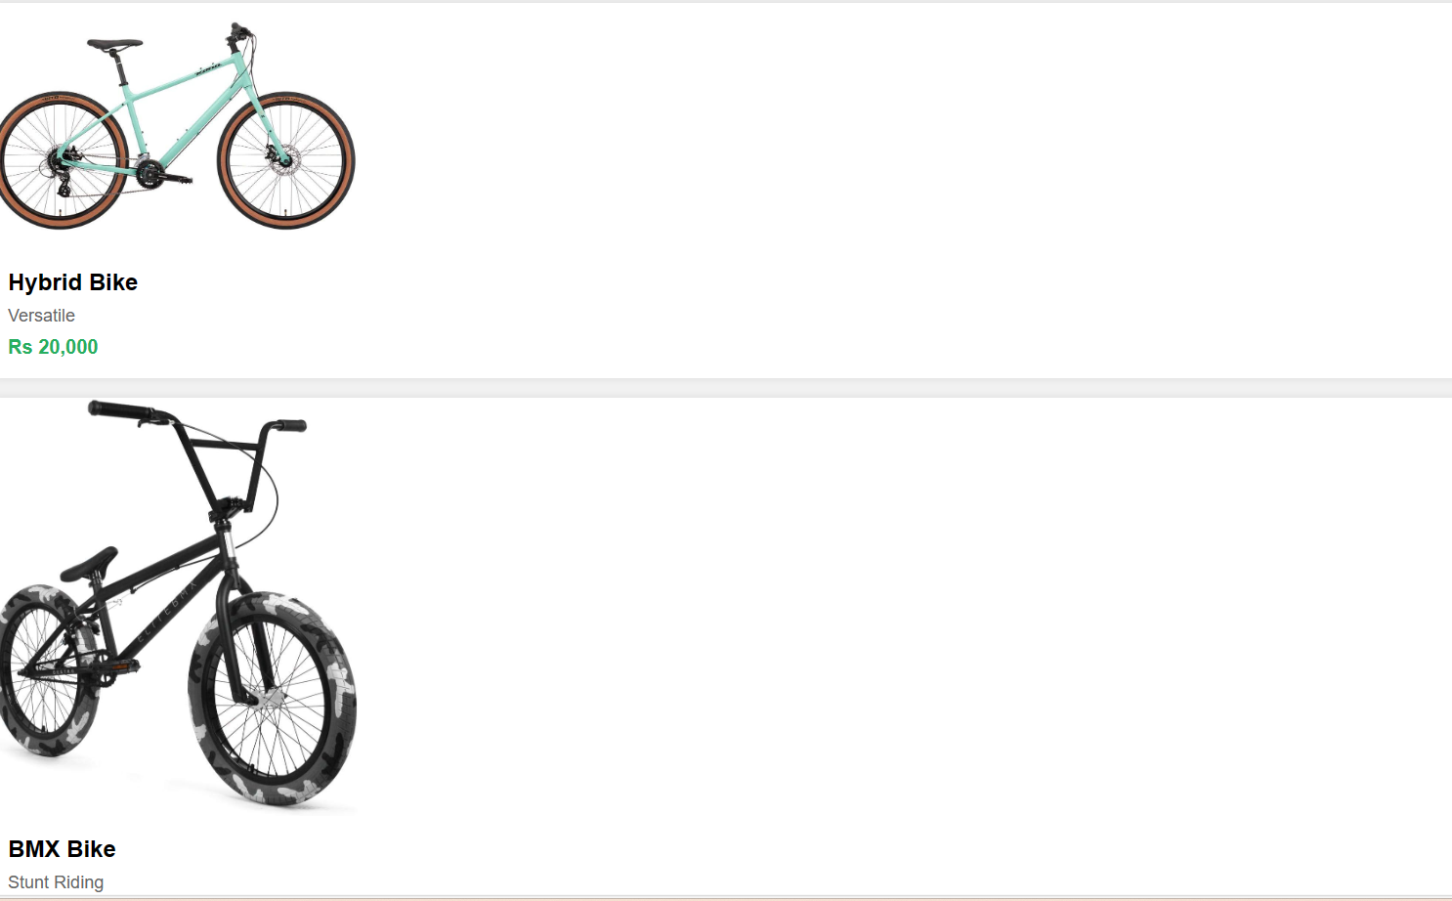

**Figure 10: -** Different types of cycles available

**21**

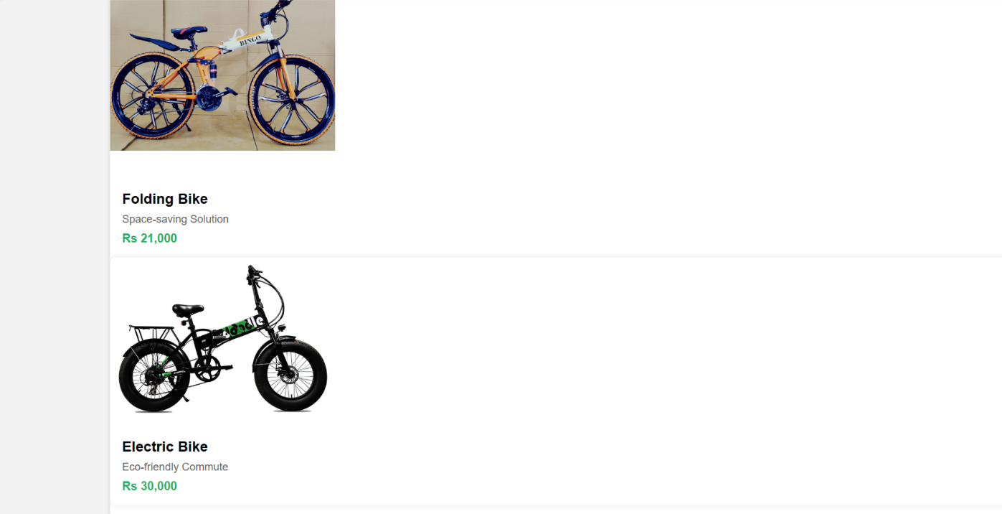

**Figure 11: -** Different types of cycles available

**8.7 Sign up Page**

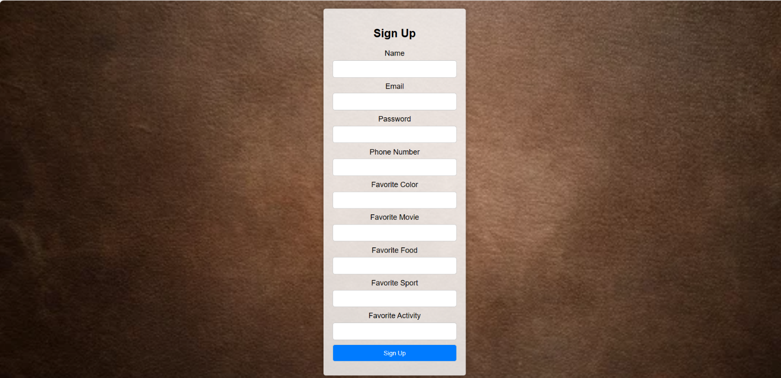

**Figure 12: -** Sign up page

**22**

**9 CONCLUSIONS**

The "Flying Wheel" cycle shop web page aims to revolutionize the cycling industry by providing a comprehensive online platform that caters to the diverse needs of cyclists. Through its user-friendly interface and commitment to promoting cycling culture and sustainability, "Flying Wheel" seeks to become the go-to destination for cycling enthusiasts.

**23**

**10 REFERENCES**

Database connectivity[: https://youtu.be/zpTJ6dtOxA?si=RYhnQLic7K8shPiz](:%20https:/youtu.be/zpTJ6dtOxA?si=RYhnQLic7K8shPiz)

Html and css[: https://youtu.be/PgAZ8KzfhO87si@mpXtx9XYc5KgpSIC](:%20%20https://youtu.be/PgAZ8KzfhO87si@mpXtx9XYc5KgpSIC)

Installing XAMPP, VS Code + Environment Setup:

<https://youtu.be/at19OmH2Bg4?si=IuKiFN787Jz6BA7m>

**24**